Azure Fee Management System
Technical Documentation & Deployment Guide
Prepared by: Tuba Ansari
Date: June 2026
Azure Subscription: Azure for Students
Region: UAE North
Resource Group: RG-FeeManagement
1. Solution Overview
A cloud-native student fee management system that automates fee notifications, provides secure APIs for fee management, and implements role-based access for students and administrators.
Key Features:
- Daily automated email reminders for pending dues
- Public API for students to check fee status
- Secure admin API with Azure AD authentication + RBAC
- Rate-limited API gateway (5 calls per 60 seconds)
- Application Insights monitoring
Technologies Used:
Service | Purpose
Azure SQL Database | Student & fee data storage
Azure Functions (Python) | API logic
Azure Logic Apps | Automated email workflow
Azure API Management | API gateway + rate limiting
Azure AD | Authentication + RBAC
Application Insights | Monitoring & diagnostics
Office 365 Outlook | Email delivery
2. Solution Architecture
Architecture Diagram :
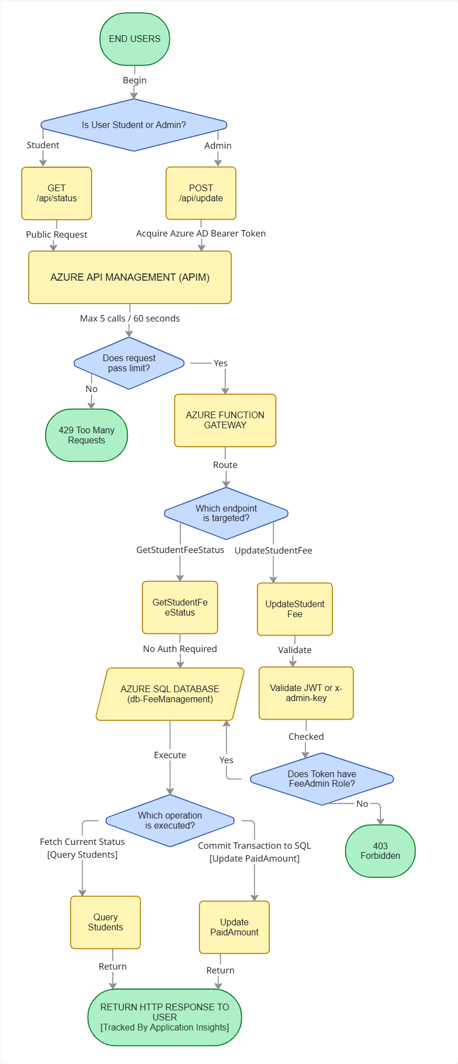
Daily Automation Workflow:
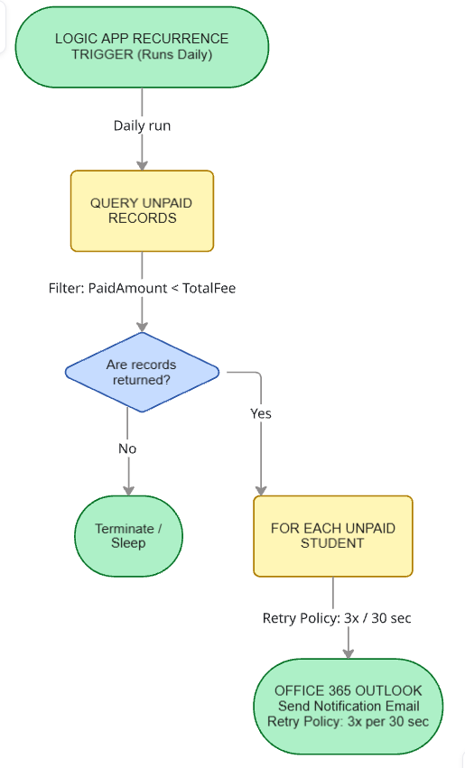

Data Flow:
- Student: Makes GET request → APIM applies rate limit → Function queries SQL → Returns JSON response
- Admin: Gets Azure AD token → POST with Bearer token → Function validates token & RBAC role → Updates SQL → Returns confirmation
- Automation: Logic App runs daily → Queries unpaid students → Sends personalized emails via Outlook
3. Technical Implementation
3.1 Database Schema
CREATE TABLE Students (
StudentID INT PRIMARY KEY IDENTITY(1,1),
Name NVARCHAR(100) NOT NULL,
Email NVARCHAR(100) NOT NULL,
Course NVARCHAR(100) NOT NULL,
TotalFee DECIMAL(10,2) NOT NULL,
PaidAmount DECIMAL(10,2) NOT NULL DEFAULT 0,
DueDate DATE NOT NULL
);
CREATE TABLE Administrators (
AdminID INT PRIMARY KEY IDENTITY(1,1),
Name NVARCHAR(100) NOT NULL,
Email NVARCHAR(100) NOT NULL,
Role NVARCHAR(50) NOT NULL
);
Sample Data: 20 students with varied payment statuses (Paid, Partially Paid, Pending) + 1 admin record.
3.2 Azure Functions (Python)
GetStudentFeeStatus — Public GET endpoint
- Accepts StudentID as query parameter
- Queries database and returns fee details with status
- Status logic: Paid (PaidAmount ≥ TotalFee) | Partially Paid (0 < PaidAmount < TotalFee) | Pending (PaidAmount = 0)
UpdateStudentFee — Secure POST endpoint
- Validates Azure AD JWT token (primary) OR x-admin-key header (fallback)
- Checks for FeeAdmin role in token claims
- Updates PaidAmount for the specified student
- Returns confirmation or appropriate error
Key Code Decisions:
- pymssql used instead of pyodbc (works on Azure Linux without ODBC drivers)
- Environment variables store all secrets: DB_PASSWORD, ADMIN_KEY, AZURE_TENANT_ID, AZURE_CLIENT_ID
3.3 Logic App Automation
Workflow:
1. Recurrence trigger runs daily
2. Get rows from SQL with filter: PaidAmount lt TotalFee
3. For each row, send personalized email via Office 365 Outlook
Email Template:
Dear [Name],
This is a reminder that your fee payment is due.
Course: [Course]
Total Fee: [TotalFee]
Amount Paid: [PaidAmount]
Due Date: [DueDate]
Please clear your dues as soon as possible.
Regards,
Fee Management Team

Retry Policy: Fixed interval, 3 retries, 30-second interval on both SQL query and email actions.
Why Outlook over SendGrid: SendGrid free tier (100 emails/day) was exhausted during testing. Outlook has no daily limits and works natively with Microsoft accounts.
3.4 Azure AD Authentication
- App Registration: Fee Management Admin
- Authentication Flow: Client obtains JWT token via OAuth2 client credentials flow → Token sent in Authorization: Bearer header → Function validates token signature using Azure AD public keys → Checks FeeAdmin role claim → Authorizes or rejects
- Fallback: x-admin-key: Secure@dmin header for automated testing scenarios where token flow is impractical.
3.5 API Management
- Configuration: Consumption tier, gateway URL https://apim-fee-mgmt.azure-api.net
- Rate Limiting Policy:
<rate-limit calls="5" renewal-period="60" />
- Note: APIs were added manually via HTTP because auto-import from Flex Consumption Function Apps has a known compatibility issue with APIM discovery.
3.6 Application Insights
Enabled directly from Function App portal. Automatically collects:
- HTTP requests with status codes
- Function execution duration and success rates
- Exceptions and error stack traces
- SQL dependency call times
4. Deployment Guide
Prerequisites
- Azure student account
- VS Code with Azure Tools and SQL Server (mssql) extensions
- Python 3.11
- Azure Functions Core Tools
Step 1: Database Setup
1. Create resource group: RG-FeeManagement (UAE North region)
2. Create SQL Server: server-fee-mgmt-ats (SQL authentication, username: azureuser)
3. Create SQL Database: db-FeeManagement (Serverless tier)
4. Add your client IP to firewall rules
5. Connect via VS Code mssql extension and run the CREATE TABLE and INSERT scripts
Step 2: Deploy Azure Functions
1. Create Function App: func-fee-api-ats (Python 3.11, Flex Consumption)
2. Add environment variables: DB_PASSWORD, ADMIN_KEY, AZURE_TENANT_ID, AZURE_CLIENT_ID
3. Deploy code from VS Code using 'Azure Functions: Deploy to Function App'
Step 3: Configure Azure AD
1. Create App Registration: Fee Management Admin
2. Note the Application (client) ID and Directory (tenant) ID
3. Create a client secret and save the value
4. Create an app role: FeeAdmin (Value: FeeAdmin)
5. Update Function App environment variables with tenant ID and client ID
Step 4: Configure Logic App
1. Create Logic App: la-fee-remainders (Consumption plan)
2. Build workflow: Recurrence → Get rows (filter: PaidAmount lt TotalFee) → For each → Send email
3. Add retry policy on both SQL and email actions
4. Test by triggering manually and checking Gmail inbox
Step 5: Setup API Management
1. Create APIM: apim-fee-mgmt (Consumption tier)
2. Add API manually via HTTP (auto-import doesn't work with Flex Consumption)
3. Add rate limiting policy: 5 calls per 60 seconds
4. Test via APIM gateway URL
Step 6: Enable Monitoring
1. Turn on Application Insights from Function App monitoring section
2. Wait a few minutes and verify data collection
5. API Reference
GET /api/GetStudentFeeStatus
- Method: GET
- Auth: None (public)
- Query Parameter: StudentID (required, integer)
- Response: JSON with Name, Course, TotalFee, PaidAmount, DueDate, Status
- Sample: https://func-fee-api-ats.azurewebsites.net/api/GetStudentFeeStatus?StudentID=1
{
"StudentID": 1,
"Name": "Aarav Sharma",
"Course": "B.Tech CSE",
"TotalFee": 85000.0,
"PaidAmount": 85000.0,
"DueDate": "2025-06-30",
"Status": "Paid"
}
POST /api/UpdateStudentFee
- Method: POST
- Auth: Azure AD Bearer token (primary) OR x-admin-key: Secure@dmin (fallback)
- Body: {"StudentID": 3, "PaidAmount": 45000}
- Response: Success message or error with appropriate HTTP status
Error Codes:
- 400: Missing or invalid parameters
- 401: Invalid or missing authentication
- 403: Authenticated but missing FeeAdmin role
- 404: Student ID not found
- 500: Server error

6. Key Technical Decisions
Decision | Why
Python over C# | Simpler, faster development, works on Linux
pymssql over pyodbc | Works on Azure Linux without ODBC drivers
Outlook over SendGrid | No daily email limit, Microsoft-native
Serverless SQL | Auto-pauses saving student credits
Flex Consumption | Supports Python on Linux, scales to zero
Azure AD + RBAC | Production-grade security, assignment requirement
x-admin-key fallback | Practical for testing and automated systems
Manual APIM import | Flex Consumption has auto-import compatibility issue
7. Troubleshooting
"Client with IP not allowed" → SQL Server → Networking → Add your current IP
"Database is paused" → Go to portal → Resume database → Wait 2-3 minutes
"Login failed" → Verify username and password, check connection string
"For Each expression is null" → No unpaid students found → Add test student with dues
"Token invalid" → Azure AD token expired → Re-run token acquisition
"APIM auto-import failed" → Add API manually via HTTP option

8. Resources Created
Resource | Name
Resource Group | RG-FeeManagement
SQL Server | server-fee-mgmt-ats
SQL Database | db-FeeManagement
Logic App | la-fee-remainders
Function App | func-fee-api-ats
API Management | apim-fee-mgmt
App Registration | Fee Management Admin
Application Insights | func-fee-api-ats
End of Documentation
Document Version: 1.0 Prepared by: Tuba Ansari Date: June 2026

